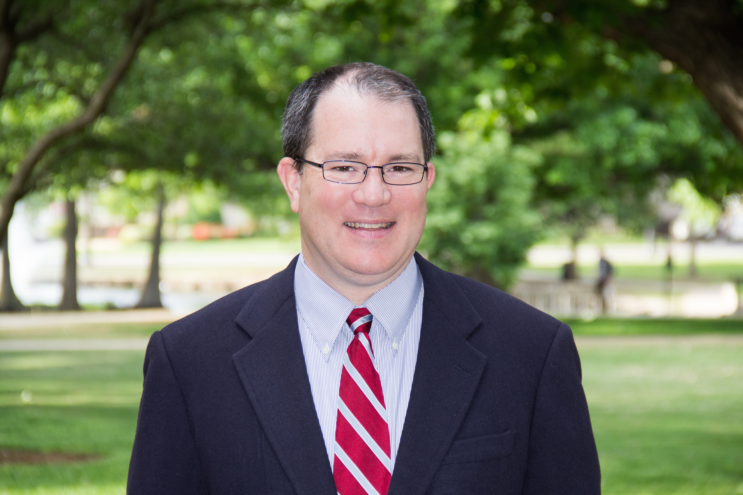
John D. Foubert, Ph.D., LLC. Author, Dean, Professor, Non-Profit Founder
405-338-8046 (cell) 192 Wyndchase Drive
John.Foubert@gmail.com Jackson, TN 38305
www.johnfoubert.com

Expert Profile: University Dean and former Endowed Professor providing experienced expert witness services specializing in sexual violence (prevention, impact, PTSD, fraternities, military, all-male groups), the effects of pornography use, and college student housing. Experienced with depositions, document review, and report writing. Author of 7 books about sexual violence, 2 about campus housing, 2 about the harms of pornography. 30 years of experience as college administrator and professor. Founder of national rape prevention nonprofit. Published 45+ peer reviewed articles about topics including sexual violence in college, rape in the military, fraternities, rape trauma, bystander intervention, campus housing, and the harms of pornography. Testified before Congress, consulted by The White House, The Pentagon, and all 4 branches of the military. Adept at explaining complex research and statistics. Travels nationwide. Sample redacted report available.

Areas of Rape Neurobiology of Sexual Trauma Post Traumatic Stress Disorder (PTSD)
Expertise Sexual Assault Pornography College Student Housing
Fraternities “False” Rape Allegations College Student Development The Military Victim Behavior Colleges and Universities

Professional Dean and Professor, College of Education, Union University, 2018 to Present
Experience Highly Qualified Expert for Sexual Assault Prevention, U.S. Army SHARP Program, 2017 to 2022
Associate/Full/Endowed Professor of Higher Education and Student Affairs, Oklahoma State University, 2009-2018.
Assistant/Associate Professor of Higher Education, College of William and Mary, 2002-2009.
Assistant Dean of Students, University of Virginia, 1998-2002.
National President, One in Four (rape prevention nonprofit organization), 1998 to 2018.
Special Assistant to the Director of Residence Life, University of Maryland College Park, 2006-2008.
Acting Coordinator for Staff Recruitment and Selection, University of Maryland College Park, 2005-2006.
Assistant Coordinator for Research, University of Maryland College Park, 2004-2005.
Area Coordinator for Residence Life, University of Richmond, 2002-2004.

Education Ph.D., University of Maryland, College Park; Counseling and Personnel Services: College Student Personnel Admin, 1998.
M.A., University of Richmond, Psychology, 1992.
B.A., College of William and Mary, Psychology and Sociology, 1990.

Selected Protecting Your Children from Internet Pornography: Understanding the Science, Risks, and Ways to Protect Your Kids, 2022.
Books (of 11) How Pornography Harms: What Teens, Young Adults, Parents and Pastors Need to Know, 2017.
Lessons Learned: How to Avoid the Biggest Mistakes Made by College Resident Assistants, 2nd Ed., 2014.
The Men’s and Women’s Programs: Ending Rape Through Peer Education, 2011.

Expert Witness Lake City Law Group, Mikolas v. University of Idaho, 2019
Clients White and Weddel, Nave v. Panama (OK) Public Schools, 2018
(Selected) Sawicki Law, Doe vs. Joseph McGregor Andrews, 2016
Stinnett Law Group, Gibson v. Sapulpa, 2016
Ivy, Barnum & O’Mara, Elbardissy v. Wesleyan, 2016
Sill Law Group, Doe v. Independent School District No. 1 of Tulsa County, 2016
Hutchinson, Black & Cook, Abby Ross v. University of Tulsa, 2015
Fried & Bonder, Doe v. Phi Gamma Delta, Atlanta GA, 2015

Selected The White House The U.S. Marines Grand Forks Air Force Base
Consultations The United States Congress Delta Kappa Epsilon Fraternity Grace Bible Church
The Pentagon The Rand Corporation Wheaton College
The U.S. Army UNC, Chapel Hill The University of Georgia
The U.S. Air Force Oakland County Schools (MI) Oklahoma Baptist University
The U.S. Naval Academy Mississippi Coalition Against Sexual Assault Holland Hall School The U.S. Coast Guard Academy The Virginia Department of Health Arkansas Department of Health

Media Interviews The New York Times, NBC News, U.S. News and World Report, CNN, Time, CBS News, Fox News, The Associated Press NPR, USA Today, The Washington Post, PBS, The Chronicle of Higher Education, BBC, Chicago Tribune

